**NIRIKSHA JHA**

**EMPL ID: 200751**

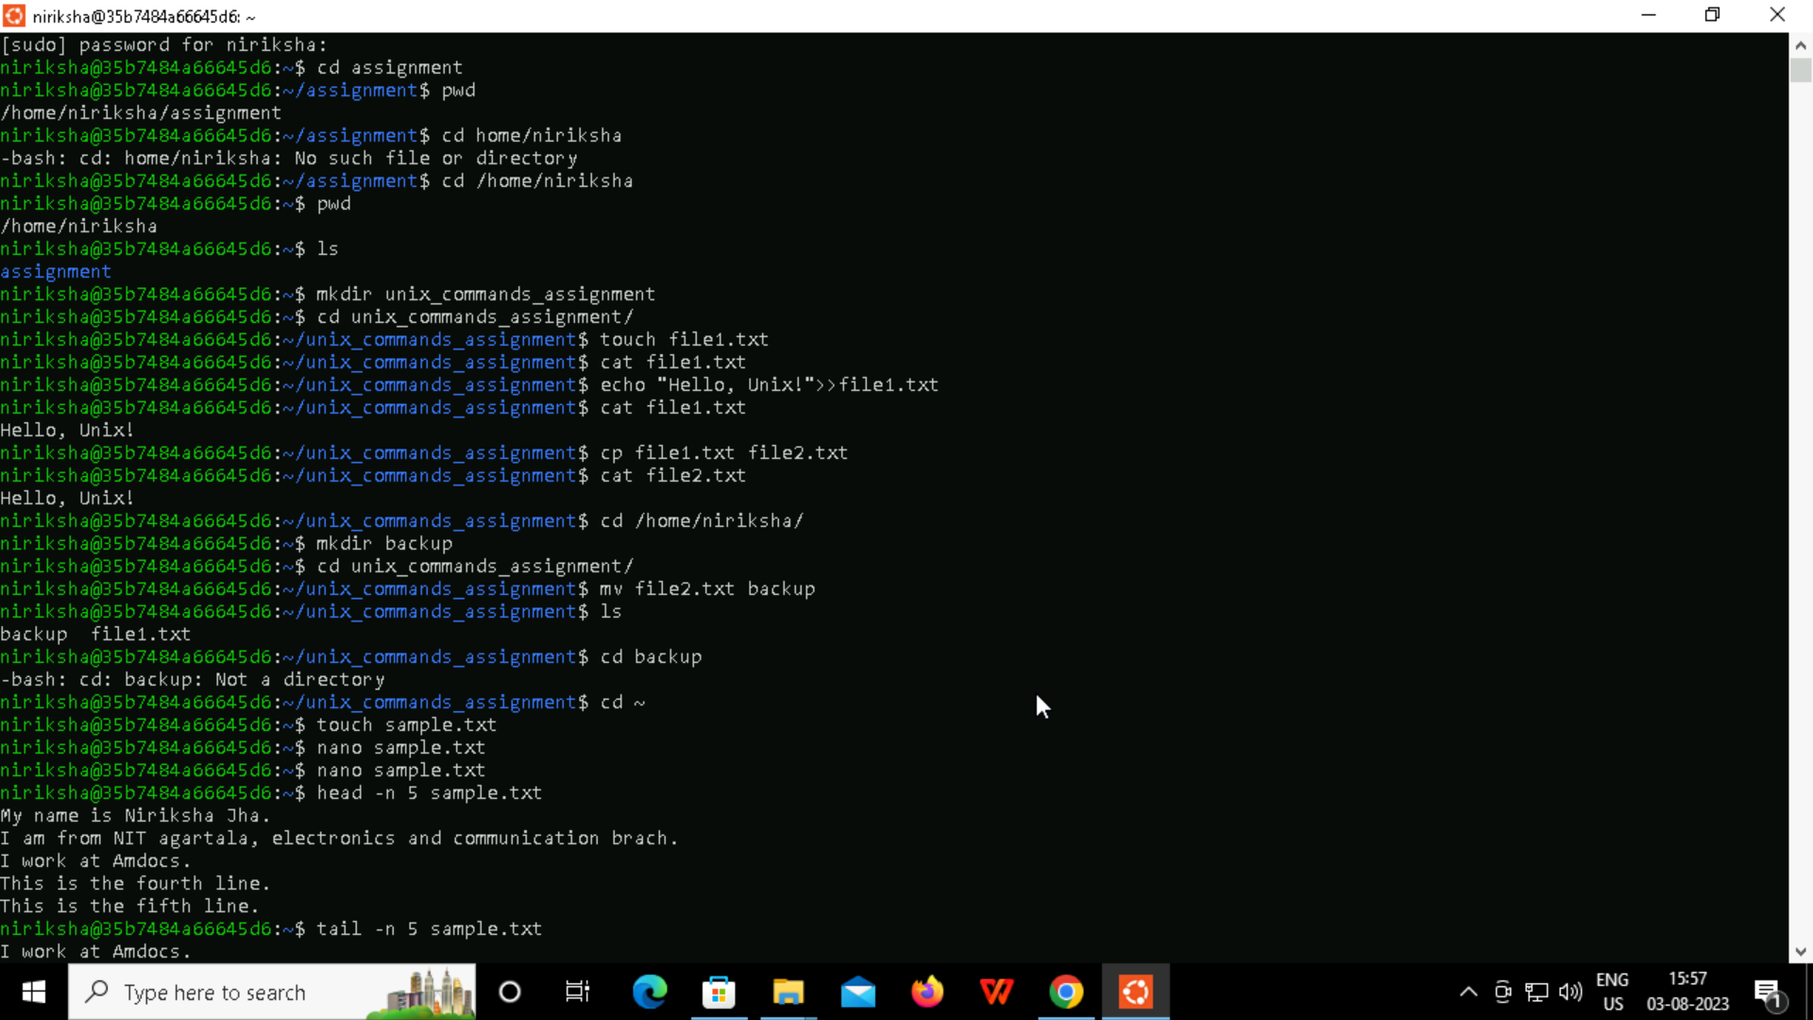

Learning UNIX today was insightful, informative and challenging as well. I found the unix command line interface to be very powerful and intuitive. The initial stages were relatively straightforward. However, as I progressed, the complexity of commands grew, presenting new and more interesting challenges . Moreover, troubleshooting errors gave me an opportunity to enhance my problem solving skills . I am excited to learn more about the unix commands and excel in the subject. Thank you.